Quantum Chromodynamics and Confinement of Quarks

Richa Shukla¹, Dr. Oriza Kamboj²
¹Department of Physics,
Lovely Professional University, Phagwara, Punjab, India
²Department of Physics,
Assistant Professor, Lovely Professional University, Phagwara, Punjab, India
Email ID: kambojoriza1964@gmail.com

Abstract
Quantum Chromodynamics or QCD for short is an important idea that helps us understand how some tiny things in our universe work. These tiny things are called quarks and gluons. They are stuck together by a strong force. The main thing this research paper is trying to figure out is why these quarks and gluons are stuck together which is called color confinement.
The paper starts by talking about something called the Quark Model. Why it is not enough to understand how these tiny things are put together. It shows that we need to use Quantum Chromodynamics to get it. The paper also explains some words like Non-Abelian SU(3) gauge symmetry and how gluons interact with each other and how these things make it so that quarks and gluons are stuck together. Quantum Chromodynamics is the key, to understanding all of this. The Flux-tube mechanism and the Cornell Potential show us that the potential energy of quarks increases as they move apart. This means that it would take an amount of energy to separate quarks completely which is not possible.
Lattice QCD simulations give us evidence for this idea. They show that the potential energy of quarks increases linearly as they move apart and they even allow us to visualize the flux-tube. The Dual Superconductor Model is another way to understand what is going on. It says that the vacuum behaves like a superconductor. We can test these ideas by looking at what happens when particles collide at energies. We see things like jet formation and hadronization processes which help us understand how quarks behave. The Flux-tube mechanism and the Cornell Potential are important, for understanding these processes. These studies show that being trapped is something that always happens with Quantum Chromodynamics. This is what most experts think will happen. It is also what they see when they do experiments, with Quantum Chromodynamics. Quantum Chromodynamics is something that experts really understand. They see it happening all the time when they work with Quantum Chromodynamics.

Keywords: Quantum Chromodynamics (QCD), Color Confinement, Strong Interaction, SU(3) Gauge Symmetry, Non-Abelian Gauge Theory, Gluon Self-Interaction, Asymptotic Freedom, Flux Tube Model, Color Flux Tube, Cornell Potential, String Tension, String Breaking, Hadronization, Parton Shower, Jet Formation, Hadronic Jets, Lattice QCD Simulations, Non-Perturbative QCD, Static Quark–Antiquark Potential, Dual Superconductor Model, Magnetic Monopole Condensation, Vacuum Structure of QCD, Quark–Gluon Plasma, High-Energy Particle Collisions.

Introduction
The strong interaction is a force of nature. It helps hold protons and neutrons, in the middle of an atom. This is called the nucleus. The strong interaction is very important. We have a way to understand the interaction. It is called Quantum Chromodynamics or QCD for short. QCD is a theory that explains how the strong interaction works. It talks about how quarks and gluons interact with each other. The strong interaction and QCD are crucial. They help us understand what protons, neutrons and mesons are made of. These are all types of hadrons. The strong interaction plays a role in this. According to the quark model, hadrons are not fundamental particles but rather combinations of quarks [4]. Quarks possess fractional electric charge and also carry a new type of charge called color charge [3,5]. The introduction of color charge was necessary to satisfy the Pauli exclusion principle and to properly explain hadron spectroscopy [5]. In Quantum Chromodynamics the strong interaction happens because of the exchange of gluons. These gluons have something called color charge. This is why Quantum Chromodynamics is a kind of theory called a non-Abelian gauge theory. It is really different, from the way things interact with electricity and magnetism. Quantum Chromodynamics is unique because of the way gluons work with color charge. Quantum Chromodynamics has a feature called asymptotic freedom. This means that quarks do not interact much with each other when they have a lot of energy or are very close together. When scientists do experiments with energy quarks act like they are free. When the energy is low the strong interaction, between quarks becomes very strong. This is why we never see quarks on their own. This is called quark confinement. Quantum Chromodynamics and quark confinement are related because of how quarks interact with each other at energy levels. Quark confinement is one of the most intriguing and challenging aspects of QCD [1,3]. To date, quarks or gluons have not been experimentally detected in isolated form, and they are always found in a bound state within hadrons [1]. The main goal of this chapter is to talk about the ideas of Quantum Chromodynamics. We will focus on quark confinement. This will help us understand what the strong interaction is and what hadronic matter is made of. Quantum Chromodynamics is important to understand these things. We want to know more about quark confinement and how it works in Quantum Chromodynamics. This will give us an idea of the strong interaction and hadronic matter. Quantum Chromodynamics is the key, to understanding these things.

Quark Model
The Quark Model was created to help us understand what is, inside matter. When scientists found a lot of hadrons in experiments during the 1950s and 1960s they knew there had to be something going on underneath all these particles. The Quark Model was important because scientists were finding more hadrons and they called all these particles the "hadron zoo". This made it really necessary to come up with a system to classify all these hadrons the Quark Model was a way to do that. This idea is what made people think of quarks as the things that make up matter. They are like the building blocks of everything around us. This idea came from that original thought, about quarks [4]. The idea of quarks was thought of by Murray Gell-Mann and George Zweig. They said that all hadrons are made up of things called quarks. At first people thought there were three kinds of quarks: Up quarks, Down quarks and Strange quarks. These three kinds of quarks were enough to explain the particles we knew about and the patterns we saw in experiments. The quarks are the building blocks of hadrons and the three quark flavors are still important today. Murray Gell-Mann and George Zweig came up with the model of quarks on their own.

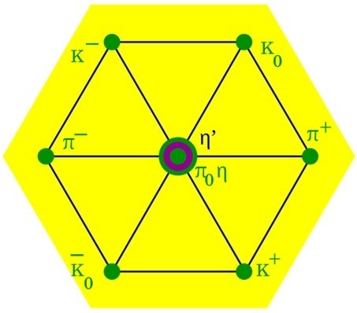

Figure 1: The Meson Octet diagram, illustrating the systematic classification of hadrons based on quark content.
The model says that hadrons are not the particles. They are actually made up of quarks combined in ways. Baryons are formed from three quarks. For example the proton is made up of quarks like this: uud. The neutron is also made up of three quarks: udd. Mesons are different. They are made up of one quark and one antiquark pair. The way quarks are arranged inside hadrons helps us understand some things, about hadrons. We can understand their charge and spin. We can also understand their moments and mass spectra. Hadrons have quarks and these quarks help us understand hadrons. Quarks have a kind of electric charge. The up-type quarks have a charge of +2/3e and the down-type quarks have a charge of -1/3e. You never see these charges on their own because quarks are always stuck together with other quarks. We can tell they are there because of the way they affect the charge of things called hadrons. For example a proton has a charge of +1e. This is because it is made up of two up quarks and one, down quark. Quarks have something called charge. That is not all they have. They also have special numbers, like baryon number and strangeness and charm and spin. All of these things help us understand how quarks work together to make hadrons. They also help us understand the rules that particles follow when they interact with each other [6].

Table 1. Fundamental Properties of Quarks
Quark Flavor | Symbol | Electric Charge | Generation
Up | u | +2/3e | First
Down | d | −1/3e | First
Strange | s | −1/3e | Second
Charm | c | +2/3e | Second
Bottom | b | −1/3e | Third
Top | t | +2/3e | Third

The discovery of particles in accelerator experiments led to the addition of three more quark flavors which are Charm, Bottom and Top. These quark flavors were added to the model. Now the model includes six flavors of quarks. This is what we use today in particle physics. The addition of these quark flavors made the quark model better, at predicting things. It also made the quark model match up with the Standard Model of particle physics that people were starting to use. The Quark Model helped us understand hadrons by putting them into groups based on how they behave and certain special numbers. This way of organizing things, which is often shown using something called SU(3) flavor symmetry allowed us to guess that some particles existed even though we had not found them yet.. It turned out that many of these particles were real and were found in experiments later on. The Quark Model is really good at predicting things, like this because it is based on the Quark Model principles. The thing is scientists found a problem when they looked at quarks that were the same. These identical quarks seemed to be in the quantum state, which did not make sense because of the Pauli Exclusion Principle [5]. This was really clear when they looked at things, like Δ⁺⁺, which is made up of three up quarks that all have their spins going in the direction [5]. So they had to figure out a way to deal with this problem. The answer was to add a quantum number, which is called color charge. This color charge idea ended up being an important part of Quantum Chromodynamics [2,5]. The Quark Model was a deal because it was the first major step in figuring out the theory of strong interaction. This model provided the ideas and math that people needed to understand how things like protons and neutrons are made up at a really small scale. The Quark Model is important for the theory of interaction and it helps us understand the structure of hadrons like protons and neutrons, at a microscopic level [2,4].

Color Charge
After the introduction of the quark model, the structure of hadrons was largely explained, but an important theoretical problem still existed [4]. Some baryons, such as the Δ⁺⁺ particle, appeared to contain three quarks of the same flavor in the same quantum state [5]. Quarks are fermions so they have to follow the Pauli Exclusion Principle. This principle says that two identical fermions cannot be in the quantum state at the same time. The Δ⁺⁺ baryon is made up of three up quarks with the spin direction. This is interesting because the Δ⁺⁺ baryon has three up quarks that are all spinning in the way. The Pauli Exclusion Principle is a rule in quantum mechanics. The fact that the Δ⁺⁺ baryon has three up quarks with spins seems to go against this rule. Quarks like the ones, in the Δ⁺⁺ baryon are fermions. Should follow the Pauli Exclusion Principle. To fix this problem physicists came up with something called color charge. Color charge is not something we can see like charge. It is like a special property that is connected to the strong interaction. This strong interaction is explained by Quantum Chromodynamics. By adding color charge physicists were able to show that identical quarks can be in states inside without breaking the Pauli principle. The color charge is a part of Quantum Chromodynamics and it helps us understand the strong interaction and the behavior of quarks. Quantum Chromodynamics and color charge are key, to understanding how quarks work. There are three types of color charge that people thought of. The color charge of red the color charge of green and the color charge of blue [2]. These names are for math and do not really mean anything when it comes to the colors we see. They are simply used to represent something in a way. The names have no connection with visual colors. Correspondingly antiquarks have what we call anticolors. Anti-red, anti-green and anti-blue. The math, behind these color states is based on something called the SU(3) gauge symmetry group, which's a big part of Quantum Chromodynamics, which is also referred to as Quantum Chromodynamics and it is the foundation of Quantum Chromodynamics.

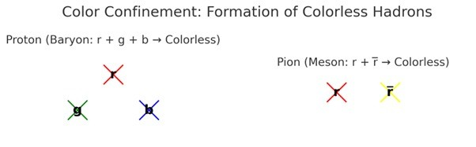

Figure 2.
Figure 2 shows the color confinement principle. This principle is about how some tiny particles called Baryons like the Proton become colorless. They do this by combining three colors. On the hand Mesons like the Pion become colorless by combining a color with its opposite, which is called an anticolor. The color confinement principle is important for Baryons like the Proton and Mesons, like the Pion.
In Quantum Chromodynamics Quantum Chromodynamics is a way of understanding how things work and hadrons are always in a state where they have no color. They are in a color singlet state. When we look at baryons we see that three quarks of colors come together in a way that their color charges cancel each other out and this makes a neutral configuration. This is similar, to when we mix three colors together and we get white light which means something is neutral. Quantum Chromodynamics helps us understand how this works in hadrons and baryons. Mesons are made up of a quark and an antiquark pair that come together in a way that a color is completely canceled out by its anti-color. This results in a state. The thing, about mesons is that they need to have color neutrality. This is a rule that Quantum Chromodynamics or QCD requires. Mesons need to follow this rule to be particles that we can see. The thing that keeps everything is what stops us from seeing free color charge in the world around us [1,2]. If we try to separate a particle that has color it always ends up creating pairs of quarks and antiquarks which means that only particles with no color are left [6]. This is basically the idea, as quark confinement, which is a pretty important principle [1]. The color charge idea fixed the problem with the Pauli Exclusion Principle. This principle was being violated because identical quarks were trying to occupy the space and spin state.. Now these quarks can do that and still be different because they have different color quantum numbers. This made the total baryon wavefunction antisymmetric again which is what fermionic statistics require. The color charge concept made sure that the Pauli Exclusion Principle was not violated by quarks. The idea of color charge is really important for understanding QCD theory. This is because the whole idea of how the strong interaction workss based on this color thing. The strong interaction is about quarks exchanging color with each other and this happens because of gluons. Gluons are like the helpers that make this exchange of color, between quarks and this is what makes the strong force work the way it does. The color charge was really important to the quark model because it made everything work together properly. This color charge was the basis for something called Quantum Chromodynamics. Quantum Chromodynamics helps us understand how hadrons are made and how they interact with each other in a way. We can learn a lot more, about hadrons and strong interactions because of this.

Gluons and Strong Interaction
Gluons are really important in Quantum Chromodynamics. They help make the interaction work. This interaction happens between quarks. It is like how photons help with the force. For the strong interaction gluons are the ones that make it happen. They go back and forth between quarks. Gluons are special because they have no mass. They are, like the photon. For the strong interaction. Gluons are connected to the color charge of quarks. This color charge is a part of the SU(3) color gauge symmetry of Quantum Chromodynamics. Gluons interact directly with this color charge. The strong interaction is special because it has no mass. This means that the strong interaction can go on forever in theory. Something called confinement stops us from seeing its effects outside of tiny things, like hadrons [1]. Gluons are different from photons in a way. The thing that sets gluons apart is that they have something called color charge. Gluons have this color charge, which's not the case, with photons. Photons do not have any charge so they do not interact with each other. Gluons are special because they have color and anti-color which means they can interact with themselves. This is a deal because it means gluons can talk to quarks but they can also talk to other gluons. They do this through something called three-gluon and four-gluon vertices, which's something that non-Abelian gauge theory says should happen. Gluons can interact with gluons, which is not something photons can do. The way QCD works with itself makes it really hard to understand. This is because QCD is not a theory. The rules that govern how gluons behave become very complicated especially when we are looking at what happens when there is not a lot of energy involved. At this point the strength of the connection between particles becomes very strong. This is a part of why the methods we use to calculate things in Quantum Electrodynamics, which is similar, to QCD do not work very well when we try to use them to understand what happens in QCD when there is not a lot of energy involved. Quarks are stuck together because they are always exchanging gluons with each other. This means quarks are always trapped hadrons. The gluons make a force that pulls quarks together. This force does not get weaker when quarks are apart. In fact, the energy in the color field gets stronger when quarks move away from each other. This is really different from forces. With forces the pull, between things gets weaker when they are farther apart. The gluon field is what makes quarks stay bound to each other. This is what keeps them inside hadrons. When people try to pull quarks the energy of the gluon field gets really strong. It gets to the point where it's easier to make a new quark and an antiquark from nothing using the idea that energy and mass are related. This new pair then joins with the quarks to make hadrons that have no color instead of letting quarks exist on their own. This is a part of why quarks are trapped and how hadrons are formed. The quarks are not allowed to be alone so they become part of a hadron. This process is important for understanding quark confinement and hadronization and quark confinement and hadronization are deals, in physics.

Table 2: Classification of hadrons based on quark composition
Category | Composition | Examples | Quark Content
Baryons | Three quarks (qqq) | Proton (p) | uud
 |  | Neutron (n) | udd
Mesons | Quark-antiquark pair (qq¯) | Pion (π⁺) | ud¯
 |  | Kaon (K⁻) | su¯

The thing about these particles is that they help us understand that gluons really do play a role in binding and confinement. We have never actually seen a quark. What we see in energy experiments are hadronic bound states. These states are formed because of the way gluons work. The existence of these particles like the hadronic bound states shows us that gluons are doing their job. This is important because it tells us that gluons are responsible, for binding and confinement
The composite particles are made up of quarks that are held together by gluons These particles are what we see in energy experiments, not free quarks The way gluons work is what forms the bound states that we observe. Gluon physics has another part, which is that there are eight different kinds of gluons. These eight kinds of gluons are related to the eight things that make up the SU(3) gauge group. Each gluon has its special mix of color and anti-color charge. This means that gluons can keep swapping color with quarks. This swapping of color is what helps keep hadrons neutral in terms of color. Gluon physics is really about how these gluons work with quarks to maintain this balance. The color exchange, between gluons and quarks is what keeps hadrons stable. Gluons are really important when it comes to QCD. They decide how strong the strong interaction is and how far it reaches. They also make the strong interaction behave in a -linear way [1,2]. The way gluons interact with themselves and exchange color is what makes them unique compared to gauge bosons in the Standard Model [3]. We need to understand how gluons work to explain things, like why quarks are confined how hadrons are formed how jets are produced and where the mass of nucleons comes from [1,4]. Gluons play a role in all of these things so understanding gluon dynamics is essential.

Non-Abelian Gauge Theory and SU(3) Symmetry
The theoretical framework of Quantum Chromodynamics is based on gauge symmetry [1]. The SU(3) gauge group is used to mathematically describe the strong interaction, representing the three independent states of color charge [2]. The symmetry structure is what defines the rules that govern how quarks and gluons interact with each other. It also makes sure that the theory of quarks and gluons is mathematically sound. In the theory of QCD, the fields of quarks change when they are affected by the SU(3) color symmetry. Because the fields of quarks have to stay the same when they are affected by these changes we need to introduce the fields of gluon gauges. In the electromagnetic interaction, there exists a U(1) Abelian gauge symmetry, where the force carrier, the photon, is electrically neutral and does not directly participate in the interaction itself [3]. The thing about Abelian symmetry is that it is linear. This means that photons do not interact with each other. Because of this Quantum Electrodynamics or QED for short is easier to understand with math. It is also solvable with perturbation theory, at energy levels [4].
In Quantum Chromodynamics the symmetry is different. It is not like the symmetry. This is because the force carriers, which are called gluons have something called color charge. The gluons have this property so they can do something that other force carriers cannot do. They can interact with quarks, which's what you would expect. They can also interact with other gluons. This happens when gluons connect directly to each other. Quantum Chromodynamics is a theory that explains how this works. The gluons in Quantum Chromodynamics are very important because they can interact with each other and, with quarks. The self-interaction terms of the interaction come from the generators of the SU(3) group that do not follow a specific order. These self-interaction terms are really important because they make the strong interaction special in ways. The strong interaction has unique features and the self-interaction terms are the reason, for this. The idea is that we have something called SU(3) gauge symmetry. Inside this symmetry there are eight kinds of gluons that can exist on their own. These eight gluons are connected to the eight generators of the SU(3) Lie algebra. They also show the ways that color and anticolor can be combined so that the total color charge stays the same. When gluons are exchanged back and forth all the time quarks are able to change the color they have. This means that hadrons, which are made up of quarks can stay neutral in terms of color. The way that color is exchanged between gluons is what holds baryons and mesons together. This is the principle that makes them stick together.
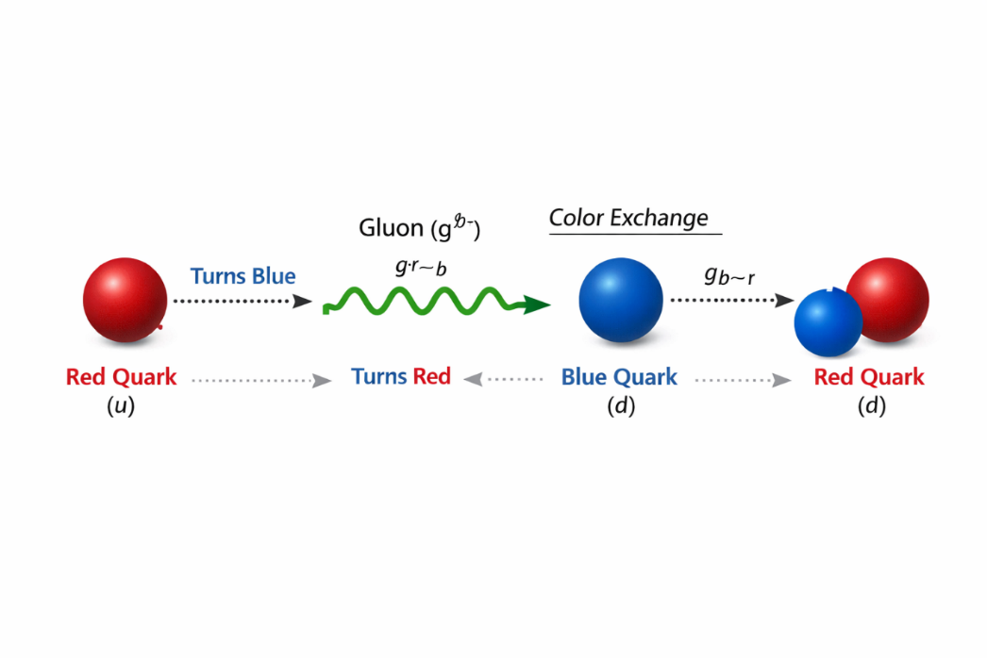

Figure 3: Representation of gluon color–anticolor combinations within SU(3) gauge symmetry.

The thing about gluons is that they interact with themselves. This makes the equations for the QCD field really complicated. Because of this the space around us or the vacuum gets really complicated too. The gluon fields start to fluctuate and do things. This is when things like color confinement and flux-tube formation start to happen. Gluons are different from forces, like electromagnetism. With electromagnetism the field lines just go out into space. Gluons are different. They stick together. Get stronger because they are interacting with each other. The coupling constant has a big effect because of the non-Abelian structure. This means that the coupling constant changes with scale. When we are talking about short distances or high energies the gluons interact with themselves in a way that makes the quarks behave almost like they are alone. When the quarks are farther apart the force, between them gets much stronger and this produces a kind of force that keeps the quarks from being separated which is what we call confinement of the quarks. The non-Abelian structure and the coupling constant are important here. The Quantum Chromodynamics theory is based on the SU(3) -Abelian gauge symmetry. This symmetry is the core of the math behind Quantum Chromodynamics. It helps us understand the interaction and how it works at a really small scale. The SU(3) non-Abelian gauge symmetry explains how gluons interact with each other and how they exchange color. Quantum Chromodynamics, which is based on the SU(3) -Abelian gauge symmetry also tells us about confinement and hadronization. It even explains why hadronic matter is stable. Quantum Chromodynamics is important, for understanding the interaction and how it affects hadronic matter.

Dual Nature of Strong Force
The self-interaction of gluons results in a non-linear behavior of the strong force, exhibiting two contrasting phenomena:

Asymptotic Freedom
When we are talking about high energies the interaction between particles becomes very weak. This happens when the distance between particles is really small, zero. At this point particles like quarks behave as if they are free and do not interact with each other. This is called Asymptotic Freedom. It is a big deal. Asymptotic Freedom was discovered by Gross, Wilczek and Politzer. They got the Nobel Prize in Physics in 2004 for their work, on Asymptotic Freedom and Quantum Chromodynamics [7]. Asymptotic Freedom is a part of Quantum Chromodynamics. The thing that really matters is the coupling constant αₛ. This can be explained in a simple way. The effective coupling constant αₛ is basically described by an expression:

$$a_{S}\left(Q^{2}\right)∝\frac{1}{\ln\left(Q^{2}∕Λ_{QCD}^{2}\right)}$$

The momentum transfer is represented by Q², which is related to the inverse distance. There is also something called the QCD scale parameter, which is denoted by $Λ$ [8]. When Q² gets really big which means we are dealing with a distance the value of αₛ gets closer to 0. This shows that the strong interaction strength gets weaker when we are talking about energies and the QCD scale parameter and Q² are important in understanding this relationship, between Q² and the strong interaction strength. The property of freedom shows that the strong interaction changes with energy. In Quantum Chromodynamics the strength of the interaction does not depend on a fixed number. Rather, on a number those changes, called αₛ [9]. This number changes with the energy of the interaction. Is figured out by looking at how things change together. The strong interaction and asymptotic freedom are connected in this way. Quantum Chromodynamics is the theory that describes the interaction. At low energy scales, corresponding to large spatial separations, the value of αₛ becomes significantly large. Under such conditions, quarks experience extremely strong attractive forces, leading to tight binding within hadrons. However, as the interaction energy increases — such as in deep inelastic scattering or high-energy collider experiments — the effective coupling strength gradually decreases [10]. So, quarks start to act like they are not interacting much with each other. They seem to be free to move inside the hadron.
Quarks are basically moving around freely inside the hadron. This is what happens with quarks when they are, inside a hadron. Quarks are the ones that are acting like this. The strange way QCD behaves comes from the way it is set up. This is different from how photons work in Quantum Electrodynamics. Gluons in QCD have something called color charge, which's not the case with photons. Because of these gluons can interact with each other, which leads to effects on the vacuum [11]. These interactions between gluons change the vacuum in a way that makes color charge behave in the way of what you would expect. Of being screened color charge is actually antiscreened. This is all because of how gluons and QCD work. QCD is special. That is why we see this unusual behavior, with gluons and color charge. So when we talk about quarks the force between them does not get stronger when they are close together. This is because of the way gluons work. Gluons make the force between quarks weaker when they are close. This is called an effect. We have seen this happen in experiments where scientists shoot particles at nucleons fast. The quarks inside the nucleons start to act like they're free when this happens [12]. This is what we see in inelastic scattering experiments, where the quarks inside the nucleons show this quasi-free behavior. The force and gluon dynamics are important here and the gluon dynamics cause this antiscreening effect, which affects the force, between the quarks. When you think about it the way the strength of this connection changes can be explained using some math equations. These equations, called renormalization group equations help us understand how the strength of Quantum Chromodynamics changes. The fact that the QCD beta function is means that the strength of the interaction gets weaker when the energy level goes up [13]. This is something about Quantum Chromodynamics and it is one of the main things that makes it work. Quantum Chromodynamics is different, from theories because of this feature. Quantum Chromodynamics is really important. This feature is a big part of what makes Quantum Chromodynamics so useful. Thus, asymptotic freedom and confinement together define two complementary regimes of the strong interaction — weak coupling at short distances and extremely strong coupling at large separations [7,9].

Color Confinement
At energies something really different happens. This is also true when we are talking about distances. The force that works between quarks actually gets stronger as the distance between them gets bigger. What this means is that it takes a lot of energy to move two of these color-charged particles from each other. In fact it takes much energy that it becomes impossible to separate them completely which is why we never see a single quark all, by itself [14].
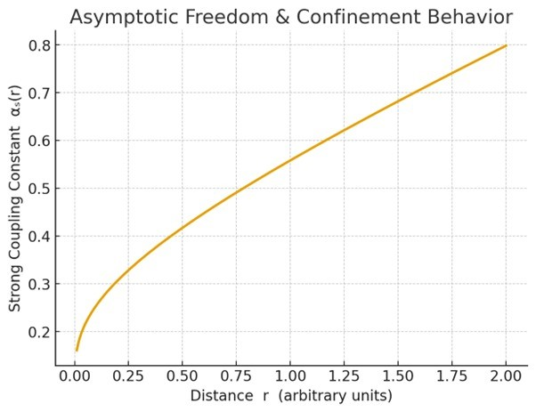
Figure 4: The dual behavior of the strong coupling constant αs(r), showing its small value at short distances (Asymptotic Freedom) and its increase at large distances (Confinement).

The main reason for this thing happening is how the strong interaction works. When two quarks are really close to each other the strong force between the quarks is not that strong. When you try to pull the quarks apart the strong force between the quarks gets stronger instead of weaker. This is totally different, from how the electromagnetic force works [15]. The strong force between quarks is something that scientists understand with the help of the gluon field. The gluon field is usually shown as a flux tube or a string. When the quarks move away, from each other the flux tube gets longer. The energy of the quark system just keeps going up [16]. At a certain point, this energy becomes so high that it is energetically favourable for the system to create a new quark–antiquark pair, instead of allowing a single quark to separate freely. This process is called string breaking [17]. Therefore, quarks are never detected in isolation, but instead, new hadrons are formed. So we never see quarks on their own what happens is that new quarks come together to form hadrons. Quarks are always part of something like these hadrons. We just do not find quarks by themselves they are always, with quarks to make new hadrons. When scientists do energy particle collision experiments they make quarks.. The quarks do not stay as quarks for long. They immediately turn into hadrons. In these experiments scientists see jets, not free quarks. This is what they actually observe. The fact that scientists see jets instead of free quarks is evidence that quarks are confined. This evidence supports the idea of quark confinement.
We do not really know for sure why colors are confined in Quantum Chromodynamics. We have a good idea of what is going on with this. We use computers to simulate what happens. This is called lattice gauge theory. These computer simulations really help us understand what the strong force does when it is acting over distances and low energies [19]. The strong force is really different when we look at quarks that are close together and when we look at quarks that are apart. When quarks are close together something called freedom helps us understand how they interact with each other.. When quarks are really far apart the strong force changes in a big way. At these distances the color field that is part of the strong force is very different from other kinds of forces, like the force that makes things attract each other, which is called electromagnetism [15]. The electric field lines that come from a charge go out in all directions. They keep going from the charge. As you get away from the charge the electric field lines get weaker. This happens because the electric field lines are spreading out. The electric field strength decreases as the distance from the charge increases. The force between charged particles like the field also gets weaker as the charged particles move farther apart. The electric field lines play a role in this because they are what carry the force, between charged particles. The situation in Quantum Chromodynamics is really different. Gluons have a property where they interact with themselves. Because of this the color field lines do not move around freely in space. The gluons actually pull on each other because of this self-interaction. This means the color field gets squeezed into a tube-like area, between the quark and the antiquark pair [16]. When quarks try to move from each other the area where they are connected does not get weaker. The energy in this area stays about the same. So the total energy in the color field that holds the quarks together gets bigger as the distance between the quarks gets bigger. The color field and the quarks are connected and the energy, in the color field keeps increasing as the quarks move further apart. The way things work with the interaction is that it does not get weaker when things are really far apart. This is different from forces like gravity or the forces that make things attract to each other. With the interaction the force between quarks stays the same no matter how far apart they are. The strong interaction has a kind of energy around it that gets stronger as things get farther apart. This means that the strong interaction does not follow the rules as gravity or those other forces that get weaker when things are really far apart [14]. The strong interaction is really good at keeping quarks connected. The force between quarks is always the same no matter what the distance is, between the quarks. When you try to pull quarks it takes more and more energy to do so. The system does not want to separate so it stores energy in the color field. This is what happens with the color field. It is a big part of how quarks work. The way the color field behaves is really important, for understanding Quantum Chromodynamics. How quarks are confined. Quantum Chromodynamics is based on this idea that quarks are confined and the color field is a part of that. The color field has a property that works over long distances. This property is what helps create flux tubes. Flux tubes are important because they give us a way to understand how quarks stay stuck together, inside hadrons. The color field and flux tubes help us see why quarks remain permanently bound within hadrons [16,19].

Color Confinement Mechanism

Formation of the Flux-Tube
The way particles are kept inside is explained by the flux-tube hypothesis [6,8,9,13]. When a quark and an antiquark start to move from each other the gluons that interact with themselves do not let the color field lines go out in all directions like they do with the electric field [6,8]. The color field lines are instead pushed into a narrow space between the quark and the antiquark making a flux-tube or color-string [8,9,13]. This flux-tube is like a string that connects the quark and the antiquark. The flux-tube hypothesis is important, for understanding how quarks and antiquarks behave. The energy between a quark and an antiquark is like this: it is modeled by the Cornell Potential [2,8,9]. This potential energy, which is the energy, between a quark and an antiquark is often represented by the Cornell Potential [2,8,9]:
$$V(r) = -\frac{4}{3}\frac{α_{s}}{r} + σr$$

The first term is, about the Coulomb- potential that is really strong when things are close together this is called Asymptotic Freedom. The second term, which is σr is the potential. The confinement potential has something to do with σ, which's the string tension and this σ is approximately one GeV/fm. When we look at the energy it grows in a straight line, which means that the energy we need to separate things is directly related to how far apart they are. This information can be found in these references [8,9,11,12,13].

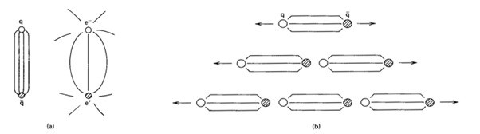

Figure.5.

Figure 5 shows something interesting. It is the difference between the electric field lines that are spreading out everywhere and the color flux lines that are stuck together. These color flux lines form a kind of tube which is also called a color string. This tube is what happens when quarks are moving away, from each other. The quarks are connected by this flux tube or color string. It is made up of the confined color flux lines that you can see on the left side of the picture.
The color field forms a kind of tube. This means that the energy of the color field is kept in a small area. This is different from what happens with interactions. With interactions the energy gets weaker as it moves away because the field spreads out.. With the color flux tube the energy inside it stays about the same all along the tube. The color flux tube has energy that is stored in it and this energy is localized. This is a thing, about the color flux tube. The idea of string tension comes from this. It is shown by the parameter σ in the term of the Cornell potential. String tension is the energy that is stored in the flux tube for each unit of length. The energy stored is really high 1 GeV for each femtometer. This means it takes a lot of energy to make the tube a little bit longer like, by subnuclear distances. The Cornell potential and string tension are related to this. String tension is an idea here. As the separation between the quark and antiquark increases, the flux tube elongates while maintaining nearly constant cross-sectional width [6,8]. Since the energy per unit length remains constant, the total potential energy of the system increases linearly with distance [8,9]. The way things work is that it makes sense why it becomes really hard to separate quarks when they get far apart. This is because quark separation becomes energetically unfavorable, beyond a limit [6,8]. The thing about this model is that it shows us something called string breaking. This happens when the energy in the flux tube gets too high. The flux tube has much energy more than it needs to make a new quark and an antiquark. When this happens the flux tube is not stable anymore. The system does not just keep getting longer and longer.
Instead it finds a way to use energy by making a new quark and an antiquark pair, from nothing from the vacuum. This is what the model of string breaking is telling us. The model of string breaking is important to understand how the flux tube and the quark and antiquark pairs work together. This newly created quark and antiquark attach themselves to the separated ends of the original tube, effectively breaking the string into two smaller flux tubes [5,8]. When we look at each of these things they make a color- hadron. So when we try to separate quarks we do not get quarks that're free but instead we get more hadronic matter like extra hadrons. The quarks form color- hadron and that is why we can not get quarks on their own we always get color-neutral hadron and more hadronic matter. The flux-tube model gives us a way to see confinement in terms of geometry and energy. It links the complicated field-theoretic description of Quantum Chromodynamics with a string-like picture. This picture is the foundation, for models that try to understand the structure of hadrons and the production of particles. The flux-tube model is really important because it helps us visualize the behavior of Quantum Chromodynamics and the structure of hadrons and particles. The flux-tube picture provides a physical visualization of quark confinement [8,13]. As the distance between a quark and an antiquark increase, the energy stored in the color flux tube increases linearly [8,9]. When you get to a point it is easier to make a new quark-antiquark pair from nothing rather than letting quarks separate forever [5,8]. This makes the string, between the quarks break and new hadrons form of free quarks [3,5]. The flux-tube mechanism explains why we never see quarks on their own in nature because quarks are always part of hadrons and the flux-tube mechanism is what makes this happen [3,8,13].

Hadronization and Jet Formation
Hadronization is the process in which free quarks and gluons convert into observable hadrons [3,4,7]. Due to color confinement, quarks can never exist in an isolated form [8,13]. So when quarks are made in crashes of tiny particles they change into hadrons before we can see them directly [4,10]. Quarks have to go through this change, which is called hadronization before we can detect the quarks themselves. When someone tries to pull a quark and an antiquark apart the thing that connects them called a color flux tube starts to get. As the quark and the antiquark get apart the energy that is stored in the color flux tube keeps going up. This happens because the energy that keeps the quark and antiquark stuck together is related to how apart they are. The color flux tube and the quark and antiquark are like connected in such a way that the more you stretch the color flux tube the energy it holds. The stored energy gets really high at some point. This is when something new happens. According to Einsteins idea that energy's equal, to mass times the speed of light squared a new pair of quark and antiquark is made out of nothing. This pair is created from the vacuum. This causes the flux tube to break. People also call this process string breaking. The created quarks then come together with the original quarks to form things called color-neutral hadrons. This whole thing is what we call hadronization. When scientists do these energy experiments this thing happens over and over. It makes a lot of hadrons that go in a line because the quarks they come from are moving really fast. This is something that scientists have seen before [4,10,18]. The high energy experiments are what make the parent quarks have much momentum and that is why the hadrons travel in a narrow direction.
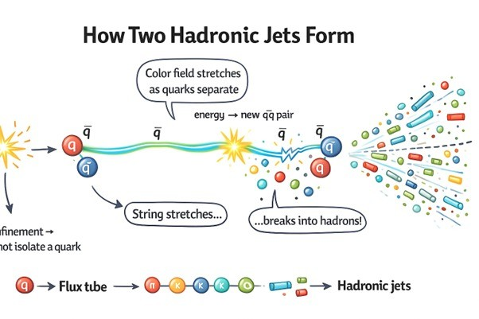
Figure 5: The Hadronization process is really interesting. It starts with the Hadronization process. The Hadronization process has a stretching color string also known as a flux tube and this breaks when the energy of the Hadronization process gets too high. This break happens because the energy of the Hadronization process exceeds the pair creation energy. When this happens the result is streams of color- hadrons, from the Hadronization process.
The thing, about hadronization is that it is one of the things that happens in Quantum Chromodynamics that we do not really understand. When the flux tube breaks and a quark and an antiquark are created these new particles cannot just stay on their own with color. The quark and the antiquark have to change. This change happens many times until we get hadrons that are stable and have no color. This process of hadronization is important because it helps us understand how Quantum Chromodynamics works with hadrons. When the string breaks the high-energy quarks and gluons start to send out gluons. These gluons can then make quark and antiquark pairs. This process of making more particles is called a parton shower. At this point the energy that was, in one place is now spread out among partons that are all moving in about the same direction. The parton shower is a thing to understand and the quarks and gluons are a big part of it. The energy of the quarks and gluons is what makes the parton shower happen. When the energy of the Quantum Chromodynamics system gets lower the calculations using Quantum Chromodynamics become useless. At this point the Quantum Chromodynamics system enters a regime that's not perturbative. The quarks and gluons, in the Quantum Chromodynamics system combine to form mesons and baryons through processes called fragmentation. This is the stage where the Quantum Chromodynamics system uses fragmentation functions to describe how the energy of the partons is shared among the hadrons that are produced. The fragmentation functions are used to do this in a way that can be observed. Because the originating partons possess high momentum, the resulting hadrons are emitted in highly collimated streams [4,10,18]. These streams are something that scientists see in their experiments as jets. They do not really find quarks when they use particle detectors. Instead these detectors show them groups of hadrons that are all moving together in a path that goes in the same direction as the original hadronic jets. This is what scientists have found out from their experiments, on jets.
Jet formation is really important because it helps us figure out what is going on with quark and gluon production. We can look at the distribution, multiplicity and energy profile of these jets to learn more about how the tiny particles inside them interact. The Large Hadron Collider is a place where scientists do experiments. They always look at jet structures to see if they match what Quantum Chromodynamics predicts. Jet formation and the study of jets is crucial in this field because it gives us a lot of information, about quark and gluon production and the interactions that happen inside jets. The way that strings break and particles come together. Then break apart again makes sure that color confinement is always followed. When people try to get quarks out by smashing things really hard what they end up with is more hadrons, not free colored particles like quarks. This is what happens because of string breaking and parton showering and fragmentation. It means that color confinement is never broken. Any time someone tries to get quarks out they will always end up with hadrons instead of free colored particles, like quarks. The diagram shows us how hadronization and jet formation happen one step at a time. First, a quark and an antiquark that're a pair move away from each other in opposite directions. This makes the color field between the quark and the antiquark get stronger of weaker and it forms something called a flux tube. The diagram illustrates the mechanism of hadronization and jet formation, in a manner. Hadronization and jet formation are things and the diagram helps us understand them by showing how a quark-antiquark pair moves and creates a color field that gets stronger and forms a flux tube. As the separation increases, the tube stretches and stores energy [8]. When the energy crosses a certain threshold, a new quark-antiquark pair is created from the vacuum through the E = mc² mechanism [5,8]. This causes the original string to break [5]. The new and old quarks recombine to form multiple hadrons [3,7]. These hadrons come out in a stream and we see this stream in the detector as hadronic jets [4,10,18]. The hadrons are all together, in this stream. We call these streams jets when we see them in the detector. The formation of jets is a good way to show that quarks are confined. This is because scientists have never been able to find a quark on its own. Jet formation provides evidence, for quark confinement. Instead what they see are the jets of hadrons that are made up of quarks. So we can see the jets that are produced but we never see the free quarks themselves.

Theoretical Evidences for Confinement

Lattice QCD Simulations

Non-Perturbative Nature Of Low Energy
The behavior of Quantum Chromodynamics depends on the energy scale [6,8,9]. In the high-energy regime, QCD is comparatively weakly coupled, where perturbative methods can be successfully applied due to asymptotic freedom [11,12]. When we look at the energy scale and it gets smaller which is the part that affects structure and confinement the strong interaction coupling constant gets really big really fast [8,9]. In this area where quarks and gluons are really connected the way they interact with each other becomes very complicated. The usual way of calculating things called perturbation theory does not work here because the math gets too messy. This is a problem because it means we cannot figure out what is going on with things, like confinement, which happens over long distances just by using math. The quarks and gluons and their behavior are just too hard to understand in this situation. This problem has forced physicists to come up with a way of doing things. A way that is not based on approximations. This new way allows physicists to really study how quarks are held together and what keeps them confined [8,9,13]. Physicists need this way to study quark binding and confinement.

Spacetime Discretization and Lattice Framework
The answer to this problem was found using something called Lattice Quantum Chromodynamics. This method involves taking the spacetime and breaking it down into small parts. It is then turned into a four-dimensional grid or lattice. Lattice Quantum Chromodynamics is used to make this grid. The grid is, like a lattice. It is used to help solve the problem. In this lattice structure, the scientists define quark fields at the places, on the lattice, which are called lattice sites like the ones we see in references [8,9]. The Gluon fields are, like a bridge that connects the sites. They do this in the form of links [8,9]. These Gluon fields are really important because they help to connect the sites. The way this is set up keeps the invariance and makes the QCD Lagrangian work well for numerical computation. We use QCD Lagrangian for this. Path integrals are a problem because they cannot be solved easily in the form. So, we use supercomputers to figure out the path integrals. We do this with Monte Carlo simulation techniques. We use these techniques, for the QCD Lagrangian. The lattice spacing is like a controller for small things and the size of the lattice controls the big picture. To get to the real-world situation we make the lattice smaller and smaller [8]. We do this by making lots of changes, to the lattice [8,9].

Linear Confinement Potential from Simulations
The important thing that Lattice QCD does is calculate the static quark-antiquark potential. This is shown in some studies [8,9,13]. When you do simulations, you can see that as the distance between the quark and the antiquark gets bigger the potential energy of the quark and the antiquark also gets bigger in a way [8,9,13]. The Lattice QCD is really good, at showing this. The quark and the antiquark potential energy is a thing to understand and Lattice QCD helps us do that. This result is what we expect from the confinement term of the Cornell potential. The Cornell potential is what tells us about the force between quarks. The force between quarks does not get weaker when they are apart. The force between quarks actually stays the same. The Cornell potential is important here because it helps us understand the force, between quarks. The thing about quarks moving in a straight line is that it would take a lot of energy to separate them completely. In fact it would take much energy that it would be impossible to separate quarks to a really big distance. This idea is important because it helps us understand why quarks are never really alone. The idea that quarks are stuck together is called the confinement hypothesis. This observation is a deal because it gives us strong theoretical support, for the confinement hypothesis of quarks. The confinement hypothesis of quarks says that quarks are never really alone and this is why we need a lot of energy to separate them.

Flux-Tube Visualizations in Lattice Studies
Something cool happens when we use lattice simulations. We can actually see how the color flux is spread out. Usually, the lines of the field go out straight from the charges. When we are talking about Quantum Chromodynamics or QCD things are not the same. The color flux distribution in QCD is different, from what we see with electromagnetic field lines. When quarks separate the color field lines do not spread out. Instead, the color field lines, between the separating quarks come together. Compress. They form a tube-like structure. This structure is called a color flux tube [8,9,13]. The color flux tube is really important when we talk about quarks. The quarks and the color flux tube are connected in a way.

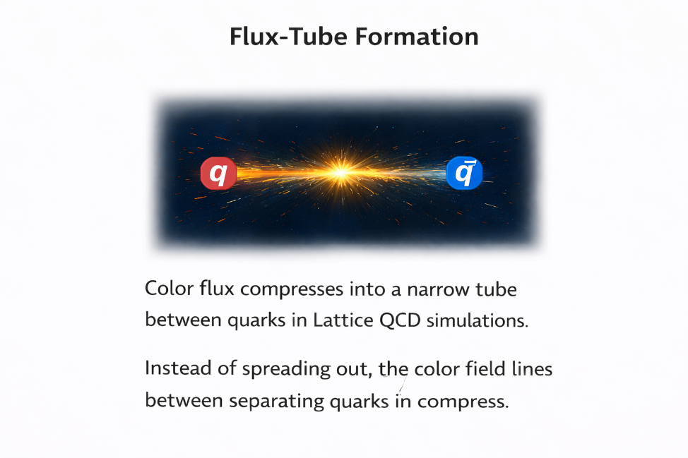

Figure 6: Visualization of color flux-tube formation between a quark and an antiquark in Lattice QCD simulations.
This tube has the amount of energy all the time and it gets longer when things move further apart. Just, like a string. The tube is a way to show that the flux-tube confinement model is correct as seen in the work of [8,9] and [8,13].

Dual Superconductor Model of Confinement

Superconductivity Analogy
The Dual Superconductor Model is a way to understand how things are kept inside. It uses a comparison with superconductivity. You see, in superconductors the magnetic field lines are pushed out from the inside of the material. This is called the Meissner effect. The Dual Superconductor Model uses this idea to explain how confinement works. The Meissner effect is important, to the Dual Superconductor Model because it helps us understand how magnetic field lines behave in superconductors. The superconductor only lets through magnetic flux tubes that are quantized. These quantized magnetic flux tubes go on to form vortex structures [8].

Duality Transformation Concept
In the superconductor picture the electromagnetic roles are basically flipped around. The idea here is that the QCD vacuum acts, like a kind of material that can conduct electricity really well. But it does this with the color-electric field, not the magnetic field. The QCD vacuum and the dual superconductor picture are important to understand this concept. In this description we talk about the idea of monopole condensation. The magnetic monopole condensation idea is introduced here. This is where magnetic monopoles come together. These magnetic monopoles that have come together make the vacuum go into a state. This special state is called a superconducting state of the vacuum. The magnetic monopoles drive the vacuum into this superconducting state.

Color-Electric Flux Confinement
The superconducting vacuum gets rid of the color-electric field lines. This means the field lines do not go out in all directions. Instead, they are. Trapped into narrow paths between quark-antiquark pairs. The dual superconducting vacuum does this to the color- field lines. It is like the superconducting vacuum is pushing the color-electric field lines together so they make narrow tubes, between the quark-antiquark pairs. These flux tubes store energy and oppose separation, keeping the quarks permanently bound [8,13].

Linear Potential from Dual Picture
The dual superconductor model says that the potential will go up in a line as the quarks move away, from each other. This is because the flux tube gets longer when the dual superconductor model pulls the quarks apart [8,9,13]. The dual superconductor model is really important here so when we talk about the dual superconductor model we are talking about how it affects the quarks.
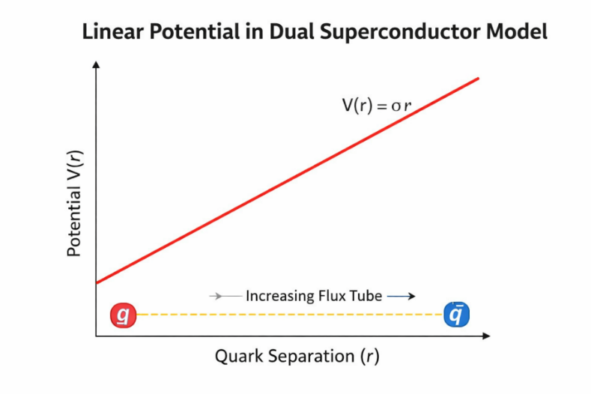

Figure 7: Linear rise of static quark–antiquark potential obtained from Lattice QCD simulations, showing confinement behavior consistent with the σr term of the Cornell potential.
This model gives us an idea of why we see certain results, in lattice QCD. It does this in a way. We still do not have experimental proof that monopoles are coming together or condensing but this model helps explain things anyway [8,9].

Theoretical Significance
The dual superconductor picture gives us a simple and easy to understand idea of how confinement works. It is not a calculation from the basic principles of Quantum Chromodynamics but the dual superconductor picture does give us a good idea of what the vacuum structure looks like and how flux is localized. The dual superconductor picture is helpful, for understanding these things even if it is not an explanation.

Table 3: Key Experimental Observations Supporting Confinement

Experiment/Observation Significance for Confinement
Hadronic Jets in Colliders  (e.g., at LHC) | Direct evidence of hadronization, where highenergy quarks (or gluons) fragment immediately into observed clusters of hadrons, rather than flying free.
Quark-Gluon Plasma  (QGP) Formation | Under extreme conditions of high temperature and density, the confinement forces are temporarily overwhelmed, resulting in a state where quarks and gluons can move quasi-freely. The QGP, however, rapidly re-confines upon cooling.
Nucleon Mass Origin | The overwhelming majority of the proton’s mass is derived from the kinetic energy and strong interaction energy of the quarks and gluons confined within it, not just the small mass of the constituent u and d quarks.

Visualization of Hadronic Jet Formation in Particle Collisions
High-energy particle collider experiments, such as the Large Hadron Collider (LHC), provide the most direct experimental environment for studying the confinement phenomenon [4,7,10]. When two high-energy particles—typically protons—collide at relativistic speeds, their constituent quarks and gluons (collectively called partons) participate in violent scattering processes [4,10].When the particles collide, a huge amount of energy is created at the point of collision making the partonic states very excited. The energy density, at the collision point is really high. However the quarks and gluons that are produced at the collision point cannot move around freely because of color confinement. This means the quarks and gluons are not able to propagate in a state. At this point the hadronization process of the quarks and gluons. This is an important part of the collision process of the quarks and gluons.

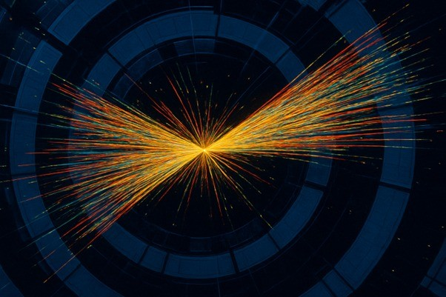

Figure 6 is a picture that shows what happens when particles collide at a detector. You can see that the energy is all focused in two areas called jets. This is proof that the hadronization processs real.
The hadronization process is what we are looking, at here and the hadronic jets are a part of the hadronization process. The picture we have shows something called a detector event. This is where tiny particles move out from the middle of a collision in two directions. These particles move together in lines and we call them hadronic jets. To understand how these jets form we need to look at what happens step by step, with the jets.
When a quark or gluon is moving fast after a collision it starts to move away from where the collision happened. The quark or gluon then goes through what's called the QCD vacuum. As the quark or gluon moves through the QCD vacuum something called a color flux tube starts to form behind it. This happens because gluons are interacting with each other. As the quark or gluon gets farther and farther away from the particles that were involved in the collision the energy that is stored in the color flux tube gets stronger and stronger. The energy in the color flux tube increases at a rate as the distance, between the quark or gluon and the other particles gets bigger.When the stored energy gets too big and crosses the line that Einsteins mass-energy relation says is important which's E equals mc squared, something called vacuum pair production happens. This makes quark-antiquark pairs. These new quarks then come together with the partons, which are the parts that make up protons and neutrons and they form color-neutral hadrons, like protons and neutrons which are stable. The energy is now stored in these hadrons, which are made up of quarks that are stuck together in a special way and this is what Einsteins mass-energy relation E equals mc squared is all about and it is also what the research, in references 5 and 7 is talking about. This thing happens over and over. It is like a chain reaction. It makes a lot of mesons and baryons that move in the same direction, as the parent parton [4,7]. When these particles get to the detector we do not see them as particles that are standing alone. Instead we see them as a bunch of tracks that spread out like a cone. This is what we call a jet [4,10]. The bright linear streaks visible in detector images represent the trajectories of charged hadrons passing through tracking chambers [4]. The thing, about having two jets right after each other is that it happens because of the way momentum works. This means that the first collision happened between two particles that were moving in opposite directions [4,10]. So the thing about jets is that they show us something. We can see that quarks and gluons are never, on their own they always turn into hadrons away. This is a good way to prove that quarks and gluons do this even if we cannot see it directly [7,8]. We are talking about quarks and gluons here. What happens to them is that they go through hadronization immediately.

The Quark Model is a way to understand how particles called hadrons are put together.. To really know how these particles interact with each other we need to look at Quantum Chromodynamics or QCD for short. Quantum Chromodynamics is like a set of rules that explains how the strong interaction works. One of the things that Quantum Chromodynamics predicts is something called color confinement. Color confinement is a deal because it says that quarks and gluons which are tiny particles that make up hadrons can never be seen on their own. This means that quarks and gluons are stuck together with other particles and we can never see a quark or a gluon by itself. The Quark Model and Quantum Chromodynamics are tools, for understanding how these particles work. Quantum Chromodynamics is especially important because it helps us understand the interaction, which is what holds quarks and gluons together. The origin of confinement comes from how gluons interact with themselves and the special structure of QCD, which is called SU(3) gauge structure. Because of this interaction color field lines do not move out into space like electromagnetic fields do. Instead they come together to form flux-tube structures. This is what happens in Quantum Chromodynamics or QCD, for short. It is because of the way gluons interact with each other and the non-Abelian SU(3) gauge structure of QCD. When you separate quarks the flux tube gets longer. The potential energy of the quarks grows as the distance between them gets bigger. It is not possible, to separate quarks completely because it would take much energy. Before you can separate quarks completely pairs of particles and antiparticles start to form from the vacuum. These particles come together to form hadrons like quarks do. The idea that particles are confined is supported by different theories. Computer simulations of Lattice QCD show that particles are held together by a linear force and that this force creates a kind of tube between them [8,9,13]. The Dual Superconductor Model helps us understand this by saying that the space around particles is like a material that pushes away certain kinds of energy called color-electric flux [8,9]. This model of the QCD vacuum is really useful for understanding how confinement works. The QCD vacuum is a part of this and the Dual Superconductor Model helps us see it as a medium that expels color-electric flux, which is an important idea, for understanding confinement and the QCD vacuum. In the field we have seen some things that really back up the idea of confinement. These things are: Hadronic jet formation in collider experiments [4,7], Properties of quark–gluon plasma [10], Deep inelastic scattering signatures of partons [4,10]. When we look at these things the collider jet events are really something to see. They give us the proof that this is real. The energetic quarks that are made when things collide hard do not just go flying on their own. Instead they show up as groups of hadrons that spray, out everywhere [4,7,8]. Color confinement is something that we see from two viewpoints, theory and experiments. It seems like the strong interaction is what makes color confinement happen. When we look at the interaction in different ways like using numbers to simulate what happens on a lattice or looking at what happens when particles collide at high energies we all come to the same conclusion about color charges. Color confinement is what happens because of the interaction. The strong interaction makes it so that color charges cannot be alone in nature. We see this when we use methods to understand the strong interaction, like non-perturbative QCD formulations, numerical lattice simulations vacuum duality models and high-energy collider observations. All of these methods tell us that color charges have to be connected to something and we cannot have isolated color charges. When we try to set quarks free we do not get particles. Instead we get hadronic matter because of flux-tube breaking and hadronization. So quark confinement is not something we observe it is a basic principle that determines how visible matter, in the universe is structured. Quark confinement is a thing that helps us understand the universe and quarks and quark confinement play a big role in this.

References

- Krane, K. S. Introductory Nuclear Physics. Wiley, 1987.
- Griffiths, D. J. Introduction to Elementary Particles. Wiley, 2008.
- Halzen, F., & Martin, A. D. Quarks and Leptons: An Introductory Course in Modern Particle Physics. Wiley, 1984.
- Perkins, D. H. Introduction to High Energy Physics. Cambridge University Press, 2000.
- Close, F. An Introduction to Quarks and Partons. Academic Press, 1979.
- Peskin, M. E., & Schroeder, D. V. An Introduction to Quantum Field Theory. Addison-Wesley, 1995.
- Povh, B., Rith, K., Scholz, C., & Zetsche, F. Particles and Nuclei. Springer, 2008.
- Greiner, W., & Schäfer, A. Quantum Chromodynamics. Springer, 1994.
- Muta, T. Foundations of Quantum Chromodynamics. World Scientific, 2010.
- Yao, W.-M. et al. (Particle Data Group). “Review of Particle Physics.” Journal of Physics G, 2006.
- Gross, D. J., & Wilczek, F. “Ultraviolet Behavior of Non-Abelian Gauge Theories.” Physical Review Letters, 1973.
- Politzer, H. D. “Reliable Perturbative Results for Strong Interactions.” Physical Review Letters, 1973.
- Wilson, K. G. “Confinement of Quarks.” Physical Review D, 1974.
- Shifman, M. A. “Quark-Hadron Duality.” Soviet Physics Uspekhi, 1979.
- Fritzsch, H., Gell-Mann, M., & Leutwyler, H. “Advantages of the Color Octet Gluon Picture.” Physics Letters B, 1973.
- Gell-Mann, M. “A Schematic Model of Baryons and Mesons.” Physics Letters, 1964.
- CERN. “Introduction to Quantum Chromodynamics.” CERN Educational Resources.
- Fermilab. “Quarks and the Strong Force.” Fermilab Particle Physics Resources.
- SLAC National Accelerator Laboratory. “Strong Interaction and QCD.” SLAC Educational Notes.
- MIT OpenCourseWare. Nuclear and Particle Physics Lecture Notes.molecular biology, 147(1), 195-197.

